**Aryaman Mishra**

**19BCE1027**

**LAB 8**

1. **Read the given adjacency matrix into R (adjacency.csv )**

library(igraph)

m=read.csv('C:\\Users\\aryam\\Desktop\\Fall Sem 2021\\Data Visualization Lab\\LAB 8 28-9-21/adjacency.csv')

print(m)

matrix=as.matrix(m)

print(matrix)



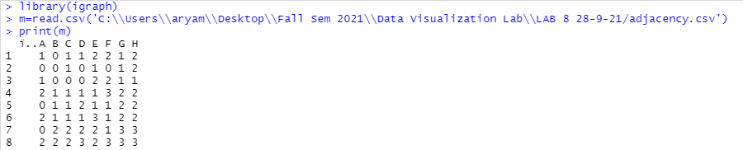

1. **Read the given edge matrix into R(edges.csv)**

#reading edge

e=read.csv('C:\\Users\\aryam\\Desktop\\Fall Sem 2021\\Data Visualization Lab\\LAB 8 28-9-21/edges.csv')

e

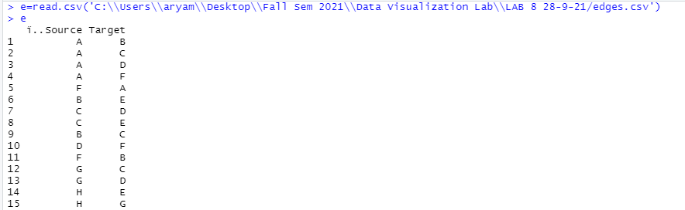

1. **Create and plot the graph from the adjacency matrix and edge matrix**

#directed graph

g=graph.adjacency(matrix,mode="directed",weighted=NULL)

plot.igraph(g,edge.arrow.size=0.1)

g

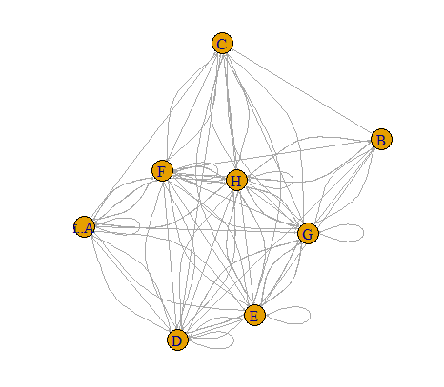

#undirected graph

g=graph.adjacency(matrix,mode="undirected",weighted=NULL)

plot.igraph(g,edge.arrow.size=0.1)

g

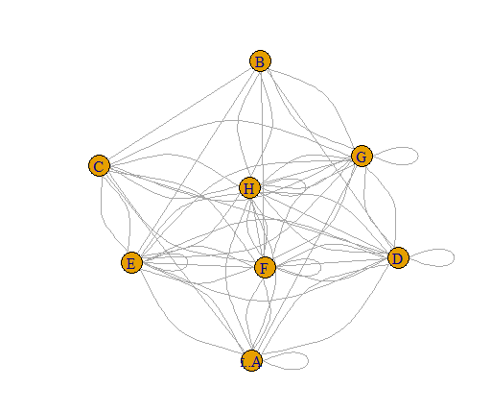

#create the network object

network=graph_from_incidence_matrix(matrix)

plot(network)

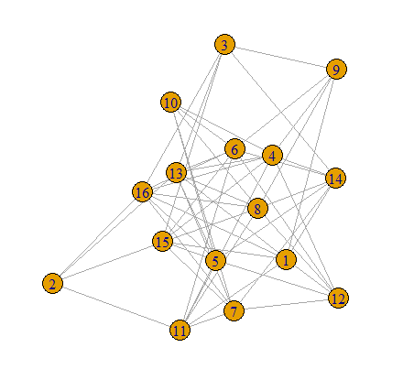

#reading edge

e=read.csv('C:\\Users\\aryam\\Desktop\\Fall Sem 2021\\Data Visualization Lab\\LAB 8 28-9-21/edges.csv')

e

#create the network object

network=graph_from_data_frame(d=e,directed=F)

plot(network)

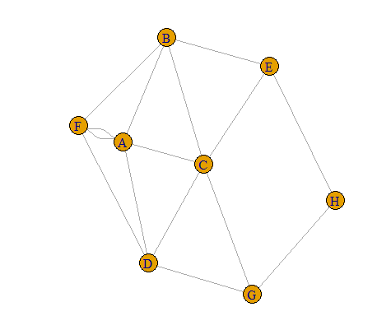

**4. Create and plot the graph from the adjacency matrix and edge matrix**

**a. customize the vertex color, shape, size**

#customize node features

#vertex customization

plot(network,vertex.color=rgb(0.5,0.7,0),vertex.shape=c("circle","rectangle","square"),vertex.size=c(50))

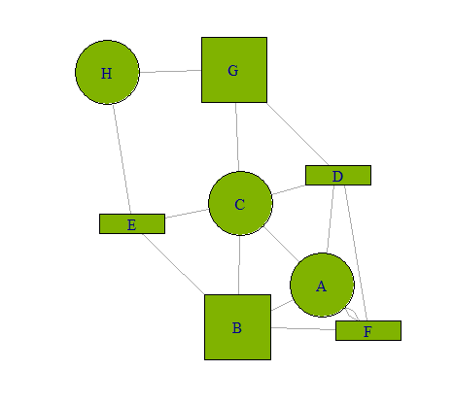

**b. edge size, edge color, vertex frame and label**

#edge customization

plot(network,edge.color=rgb(0.8,0.6,0.3),vertex.shape=c("circle","rectangle","square"),edge.size=c(80),edge.color="orange")

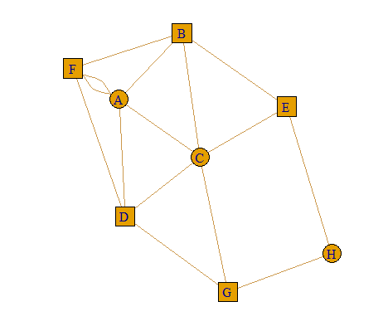

#label and frame customization

plot(network,

vertex.label=LETTERS[1:10], # Character vector used to label the nodes

vertex.label.color=c("red","blue"),

vertex.label.family="Times", # Font family of the label (e.g.“Times”, “Helvetica”)

vertex.label.font=c(1,2,3,4), # Font: 1 plain, 2 bold, 3, italic, 4 bold italic, 5 symbol

vertex.label.cex=c(0.5,1,1.5), # Font size (multiplication factor, device-dependent)

vertex.label.dist=0, # Distance between the label and the vertex

vertex.label.degree=0 , # The position of the label in relation to the vertex (use pi)

)

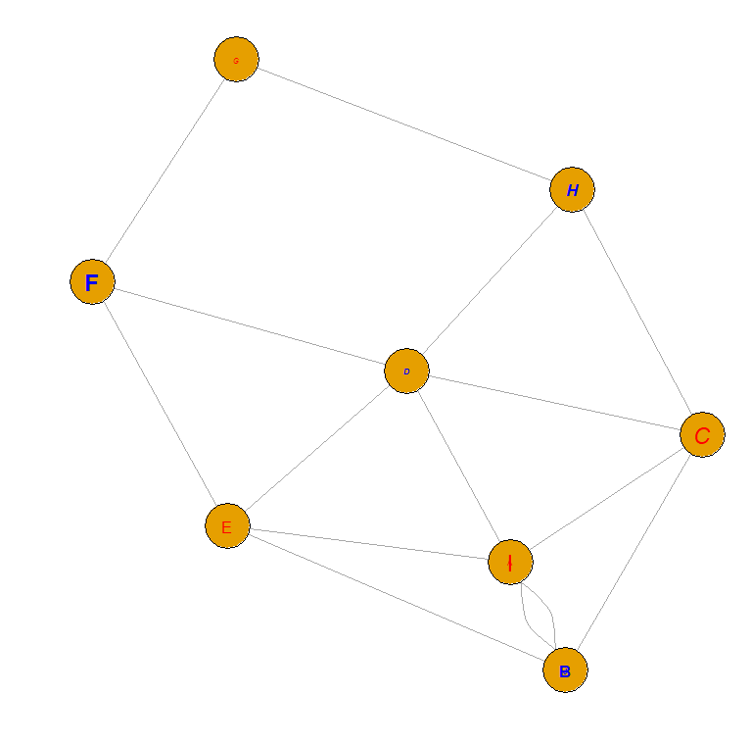

plot(network,vertex.color=rgb(0.5,0.7,0),vertex.shape=c("circle","rectangle","square"),vertex.size=c(50),vertex.frame.color="blue")

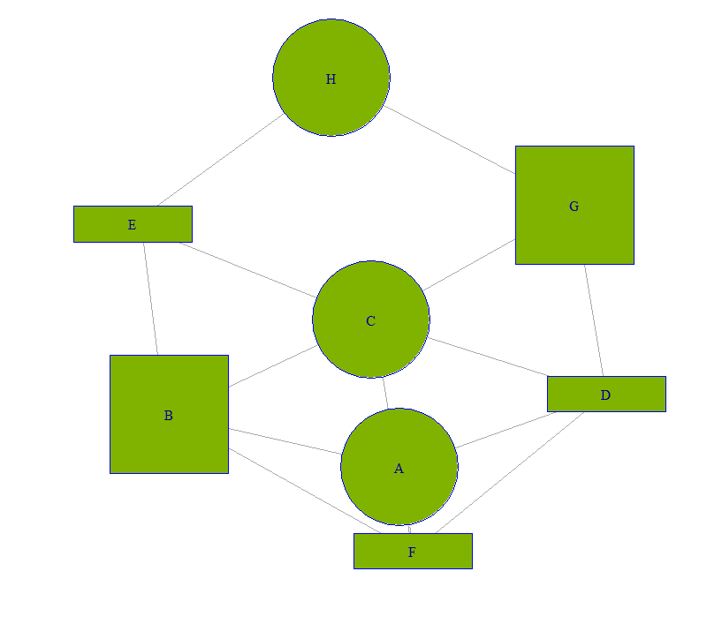

**5. Display the name of vertices, edges, no. of vertices and edges**

V(network)

E(network)

gsize(network)

gorder(network)

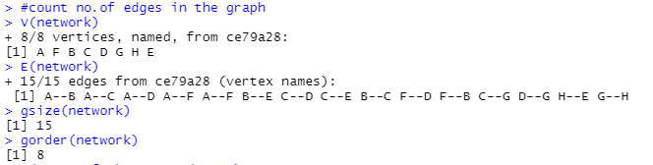

**6. Find the degree of each vertex, min and max degree of the created graph**

#degree of the created graph

deg=degree(network,mode="in")

deg

max(deg)

min(deg)

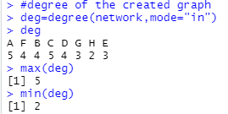

**7. Display the adjacency vertices of each vertex(individual) in the created gap.**

#adjacent vertices

adj=adjacent_vertices(network,v=1:6)

adj

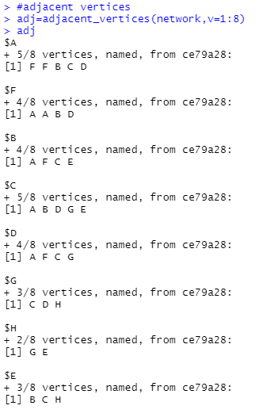

**ENTIRE R SCRIPT:**

library(igraph)

m=read.csv('C:\\Users\\aryam\\Desktop\\Fall Sem 2021\\Data Visualization Lab\\LAB 8 28-9-21/adjacency.csv')

print(m)

matrix=as.matrix(m)

print(matrix)

#directed graph

g=graph.adjacency(matrix,mode="directed",weighted=NULL)

plot.igraph(g,edge.arrow.size=0.1)

g

#undirected graph

g=graph.adjacency(matrix,mode="undirected",weighted=NULL)

plot.igraph(g,edge.arrow.size=0.1)

g

#create the network object

network=graph_from_incidence_matrix(matrix)

plot(network)

#reading edge

e=read.csv('C:\\Users\\aryam\\Desktop\\Fall Sem 2021\\Data Visualization Lab\\LAB 8 28-9-21/edges.csv')

e

#create the network object

network=graph_from_data_frame(d=e,directed=F)

plot(network)

#customize node features

#vertex customization

plot(network,vertex.color=rgb(0.5,0.7,0),vertex.shape=c("circle","rectangle","square"),vertex.size=c(50))

#edge customization

plot(network,vertex.color=rgb(0.5,0.7,0),vertex.shape=c("circle","rectangle","square"),vertex.size=c(50),edge.color="pink")

#label and frame customization

plot(network,vertex.color=rgb(0.5,0.7,0),vertex.shape=c("circle","rectangle","square"),vertex.size=c(50),vertex.frame.color="blue")

#count no.of edges in the graph

V(network)

E(network)

gsize(network)

gorder(network)

#degree of the created graph

deg=degree(network,mode="in")

deg

max(deg)

min(deg)

#adjacent vertices

adj=adjacent_vertices(network,v=1:8)

adj

**console:**

> library(igraph)

> m=read.csv('C:\\Users\\aryam\\Desktop\\Fall Sem 2021\\Data Visualization Lab\\LAB 8 28-9-21/adjacency.csv')

> print(m)

ï..A B C D E F G H

1 1 0 1 1 2 2 1 2

2 0 0 1 0 1 0 1 2

3 1 0 0 0 2 2 1 1

4 2 1 1 1 1 3 2 2

5 0 1 1 2 1 1 2 2

6 2 1 1 1 3 1 2 2

7 0 2 2 2 2 1 3 3

8 2 2 2 3 2 3 3 3

> matrix=as.matrix(m)

> print(matrix)

ï..A B C D E F G H

[1,] 1 0 1 1 2 2 1 2

[2,] 0 0 1 0 1 0 1 2

[3,] 1 0 0 0 2 2 1 1

[4,] 2 1 1 1 1 3 2 2

[5,] 0 1 1 2 1 1 2 2

[6,] 2 1 1 1 3 1 2 2

[7,] 0 2 2 2 2 1 3 3

[8,] 2 2 2 3 2 3 3 3

> #directed graph

> g=graph.adjacency(matrix,mode="directed",weighted=NULL)

> plot.igraph(g,edge.arrow.size=0.1)

> g

IGRAPH ce532ee DN-- 8 93 --

+ attr: name (v/c)

+ edges from ce532ee (vertex names):

[1] ï..A->ï..A ï..A->C ï..A->D ï..A->E ï..A->E ï..A->F ï..A->F ï..A->G ï..A->H ï..A->H B ->C

[12] B ->E B ->G B ->H B ->H C ->ï..A C ->E C ->E C ->F C ->F C ->G C ->H

[23] D ->ï..A D ->ï..A D ->B D ->C D ->D D ->E D ->F D ->F D ->F D ->G D ->G

[34] D ->H D ->H E ->B E ->C E ->D E ->D E ->E E ->F E ->G E ->G E ->H

[45] E ->H F ->ï..A F ->ï..A F ->B F ->C F ->D F ->E F ->E F ->E F ->F F ->G

[56] F ->G F ->H F ->H G ->B G ->B G ->C G ->C G ->D G ->D G ->E G ->E

[67] G ->F G ->G G ->G G ->G G ->H G ->H G ->H H ->ï..A H ->ï..A H ->B H ->B

[78] H ->C H ->C H ->D H ->D H ->D H ->E H ->E H ->F H ->F H ->F H ->G

+ ... omitted several edges

> #undirected graph

> g=graph.adjacency(matrix,mode="undirected",weighted=NULL)

> plot.igraph(g,edge.arrow.size=0.1)

> g

IGRAPH ce5ef3a UN-- 8 62 --

+ attr: name (v/c)

+ edges from ce5ef3a (vertex names):

[1] ï..A--ï..A ï..A--C ï..A--D ï..A--D ï..A--E ï..A--E ï..A--F ï..A--F ï..A--G ï..A--H ï..A--H

[12] B --C B --D B --E B --F B --G B --G B --H B --H C --D C --E C --E

[23] C --F C --F C --G C --G C --H C --H D --D D --E D --E D --F D --F

[34] D --F D --G D --G D --H D --H D --H E --E E --F E --F E --F E --G

[45] E --G E --H E --H F --F F --G F --G F --H F --H F --H G --G G --G

[56] G --G G --H G --H G --H H --H H --H H --H

> #create the network object

> network=graph_from_incidence_matrix(matrix)

> plot(network)

> #reading edge

> e=read.csv('C:\\Users\\aryam\\Desktop\\Fall Sem 2021\\Data Visualization Lab\\LAB 8 28-9-21/edges.csv')

> e

ï..Source Target

1 A B

2 A C

3 A D

4 A F

5 F A

6 B E

7 C D

8 C E

9 B C

10 D F

11 F B

12 G C

13 G D

14 H E

15 H G

> #create the network object

> network=graph_from_data_frame(d=e,directed=F)

> plot(network)

> #customize node features

> #vertex customization

> plot(network,vertex.color=rgb(0.5,0.7,0),vertex.shape=c("circle","rectangle","square"),vertex.size=c(50))

> #edge customization

> plot(network,vertex.color=rgb(0.5,0.7,0),vertex.shape=c("circle","rectangle","square"),vertex.size=c(50),edge.color="pink")

> #label and frame customization

> plot(network,vertex.color=rgb(0.5,0.7,0),vertex.shape=c("circle","rectangle","square"),vertex.size=c(50),vertex.frame.color="blue")

> #count no.of edges in the graph

> V(network)

+ 8/8 vertices, named, from ce79a28:

[1] A F B C D G H E

> E(network)

+ 15/15 edges from ce79a28 (vertex names):

[1] A--B A--C A--D A--F A--F B--E C--D C--E B--C F--D F--B C--G D--G H--E G--H

> gsize(network)

[1] 15

> gorder(network)

[1] 8

> #degree of the created graph

> deg=degree(network,mode="in")

> deg

A F B C D G H E

5 4 4 5 4 3 2 3

> max(deg)

[1] 5

> min(deg)

[1] 2

> #adjacent vertices

> adj=adjacent_vertices(network,v=1:6)

> adj

$A

+ 5/8 vertices, named, from ce79a28:

[1] F F B C D

$F

+ 4/8 vertices, named, from ce79a28:

[1] A A B D

$B

+ 4/8 vertices, named, from ce79a28:

[1] A F C E

$C

+ 5/8 vertices, named, from ce79a28:

[1] A B D G E

$D

+ 4/8 vertices, named, from ce79a28:

[1] A F C G

$G

+ 3/8 vertices, named, from ce79a28:

[1] C D H

> #adjacent vertices

> adj=adjacent_vertices(network,v=1:9)

Error in adjacent_vertices(network, v = 1:9) :

At iterators.c:759 : Cannot create iterator, invalid vertex id, Invalid vertex id

> adj

$A

+ 5/8 vertices, named, from ce79a28:

[1] F F B C D

$F

+ 4/8 vertices, named, from ce79a28:

[1] A A B D

$B

+ 4/8 vertices, named, from ce79a28:

[1] A F C E

$C

+ 5/8 vertices, named, from ce79a28:

[1] A B D G E

$D

+ 4/8 vertices, named, from ce79a28:

[1] A F C G

$G

+ 3/8 vertices, named, from ce79a28:

[1] C D H

> #adjacent vertices

> adj=adjacent_vertices(network,v=1:8)

> adj

$A

+ 5/8 vertices, named, from ce79a28:

[1] F F B C D

$F

+ 4/8 vertices, named, from ce79a28:

[1] A A B D

$B

+ 4/8 vertices, named, from ce79a28:

[1] A F C E

$C

+ 5/8 vertices, named, from ce79a28:

[1] A B D G E

$D

+ 4/8 vertices, named, from ce79a28:

[1] A F C G

$G

+ 3/8 vertices, named, from ce79a28:

[1] C D H

$H

+ 2/8 vertices, named, from ce79a28:

[1] G E

$E

+ 3/8 vertices, named, from ce79a28:

[1] B C H

**CONCLUSION:EXERCISE PROLEMS HAVE BEEN SUCCESFULLY EXECUTED.**